Bernice Under Singlet

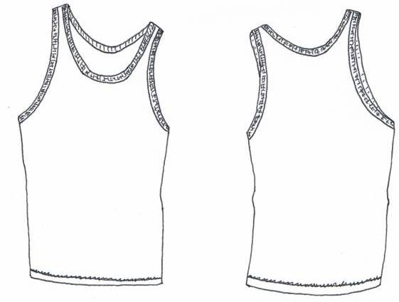

Measurement Points(cms) | XS | S | M | L
Side neck to bottom of hem | 65.5 | 67 | 68.5 | 70
Chest from armhole seam to armhole seam | 37 | 40 | 43 | 46

Rosemary Athletic Sweat

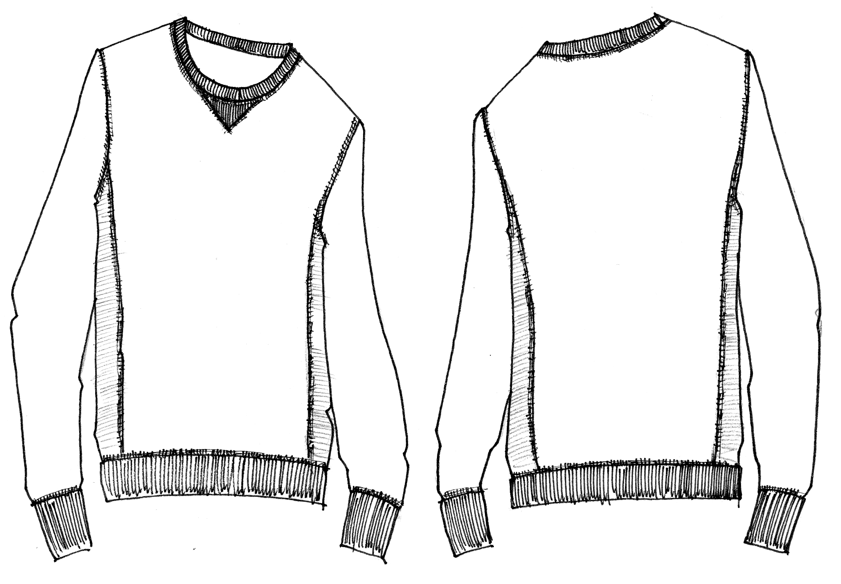

Measurement Points(cms) | XS | S | M | L
Side neck to bottom of hem | 64.5 | 66 | 67.5 | 69
Chest from armhole seam to armhole seam | 41 | 44 | 47 | 50
Sleeve length from shoulder to cuff | 65 | 66 | 64 | 65

Virginia Athletic Sweat

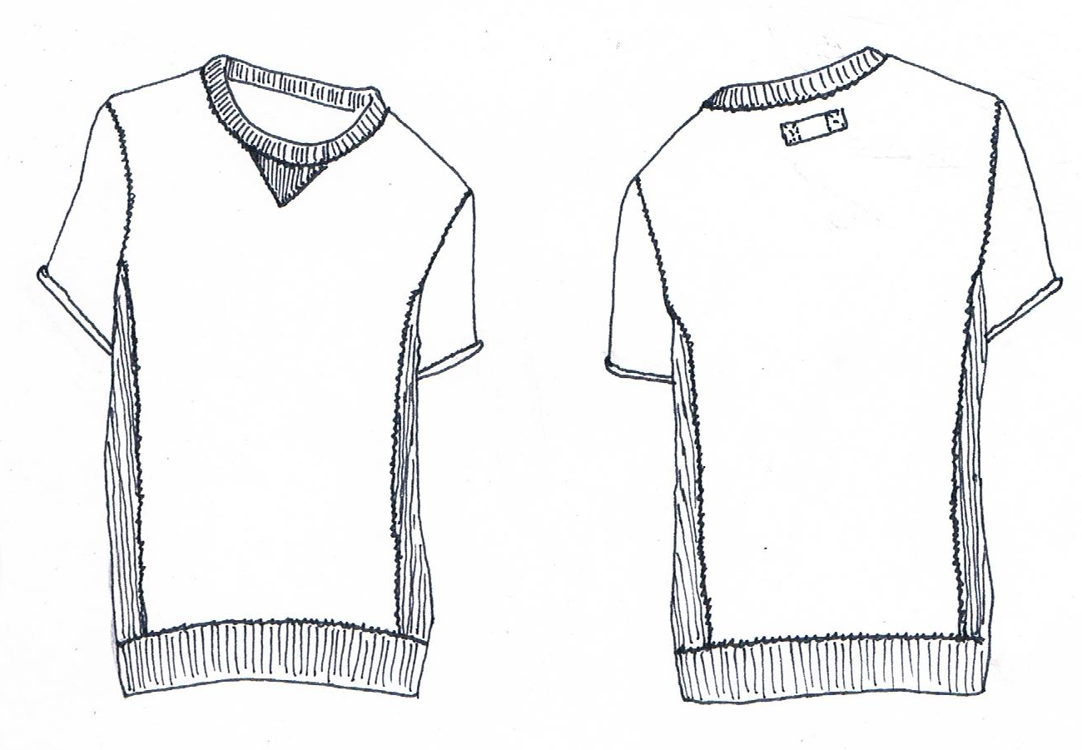

Measurement Points(cms) | XS | S | M | L
Side neck to bottom of hem | 64.5 | 66 | 67.5 | 69
Chest from armhole seam to armhole seam | 41 | 44 | 47 | 50
Sleeve length from shoulder to cuff | 13 | 14 | 15 | 16

Laurie Athletic Sweat

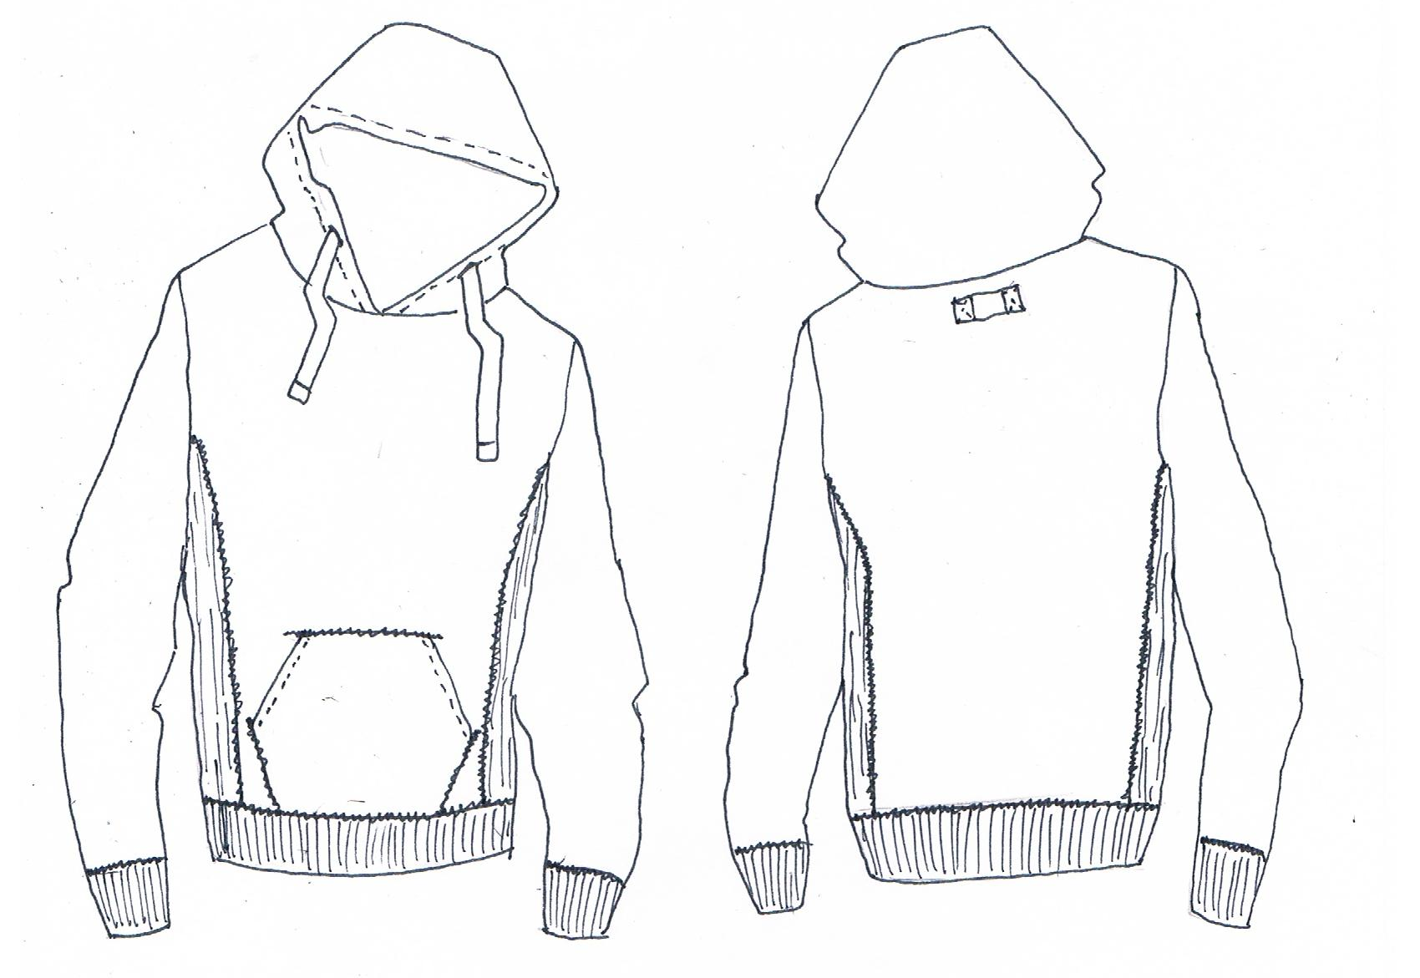

Measurement Points(cms) | XS | S | M | L
Side neck to bottom of hem | 64.5 | 66 | 67.5 | 69
Chest from armhole seam to armhole seam | 41 | 44 | 47 | 50
Sleeve length from shoulder to cuff | 65 | 66 | 64 | 65

Shirley Long Sleeve Shirt

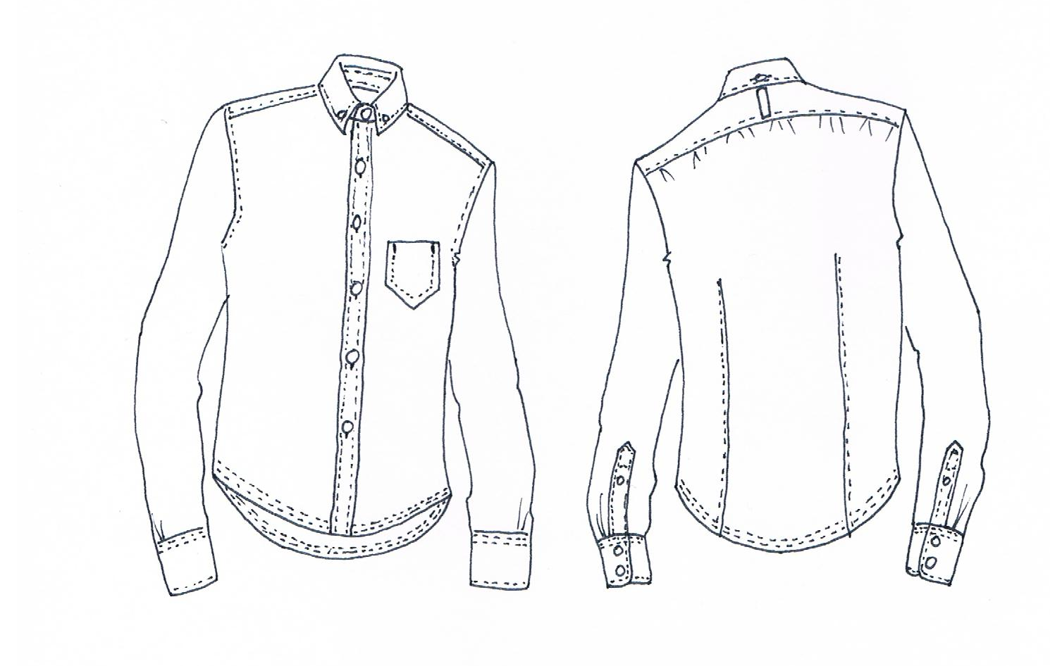
Measurement Points(cms) | XS | S | M | L
Centre back neck to bottom of hem | 70 | 71.5 | 73 | 74.5
Chest from armhole seam to armhole seam | 42 | 45 | 48 | 51
Shoulder to shoulder | 37 | 38.5 | 40 | 41.5
Sleeve length from shoulder to cuff | 60 | 61 | 62 | 63
Neck circumference(centre button to centre button hole) | 35 | 36.5 | 38 | 39.5

Harriet Trouser

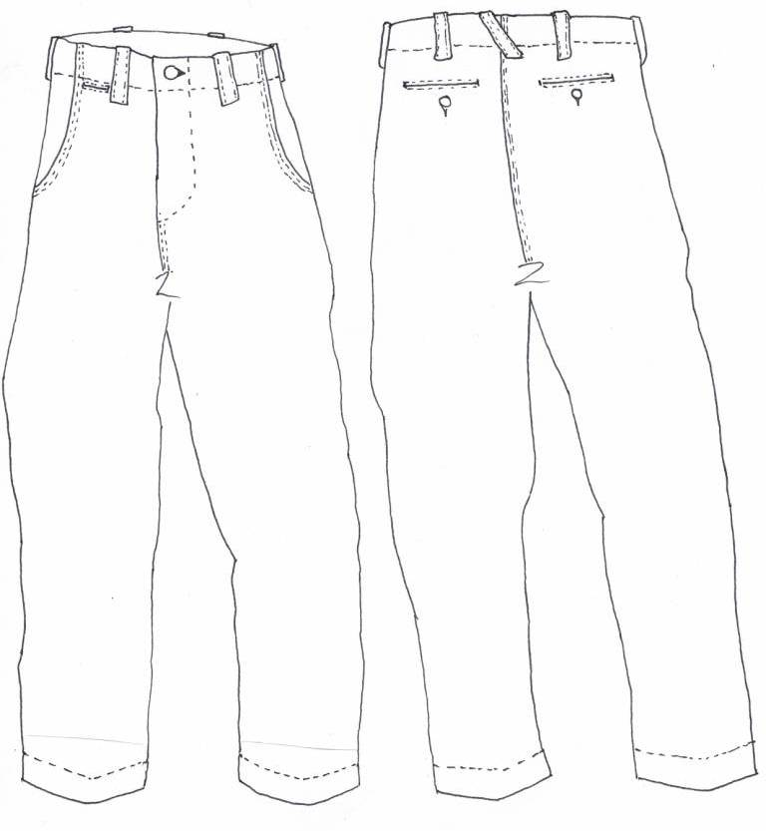

Measurement Points(cms) | 25 | 26 | 27 | 28 | 29 | 30
Half waist | 30 | 32.5 | 35 | 38 | 41 | 44
Half hip | 50 | 52.5 | 47.5 | 50 | 52.5 | 55
Half thigh | 25 | 26.5 | 28 | 29.5 | 31 | 32.5
Half hem | 16 | 17 | 18 | 19 | 20 | 21
Inseam | 83 | 83 | 83 | 83 | 83 | 83

Hattie Denim Jean

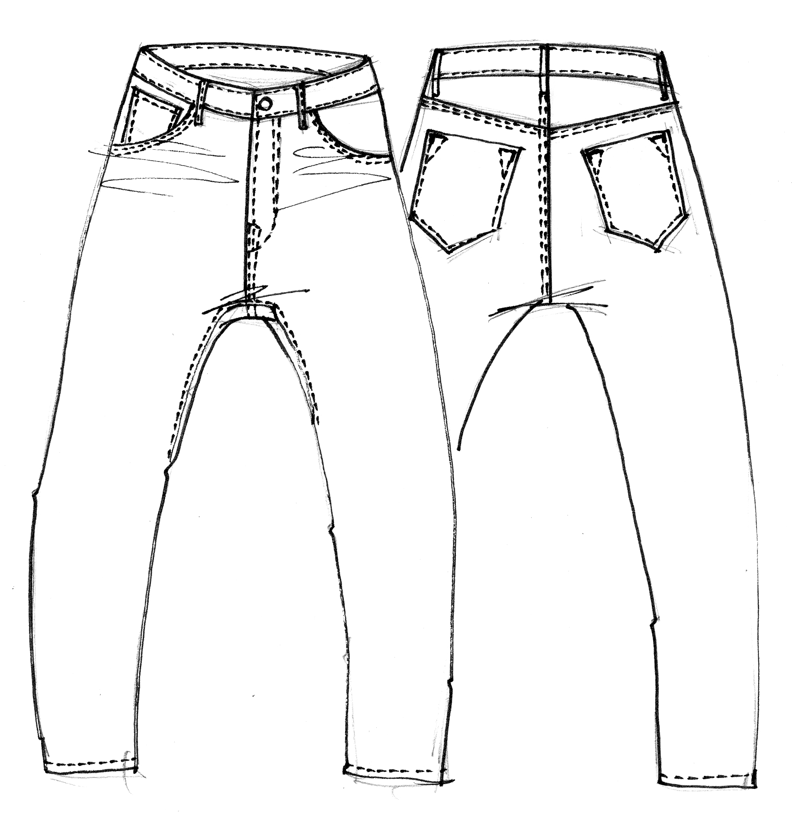

Measurement Points(cms) | 25 | 26 | 27 | 28 | 29 | 30
Half waist | 33.5 | 36 | 38.5 | 41 | 43.5 | 46
Half hip | 42 | 44.5 | 47 | 49.5 | 52 | 54.5
Half thigh | 26 | 27.5 | 29 | 30.5 | 32 | 33.5
Half hem | 14 | 15 | 16 | 17 | 18 | 19
Inseam | 83 | 83 | 83 | 83 | 83 | 83

